Algorithm and flowchart

1. Finding sum of two numbers

Step 1: Start

Step 2: Input the 2 numbers ‘A’ and ‘B’

Step 3: Perform the addition of both numbers to get value ‘C’ (C=A+B)

Step 4: Stop

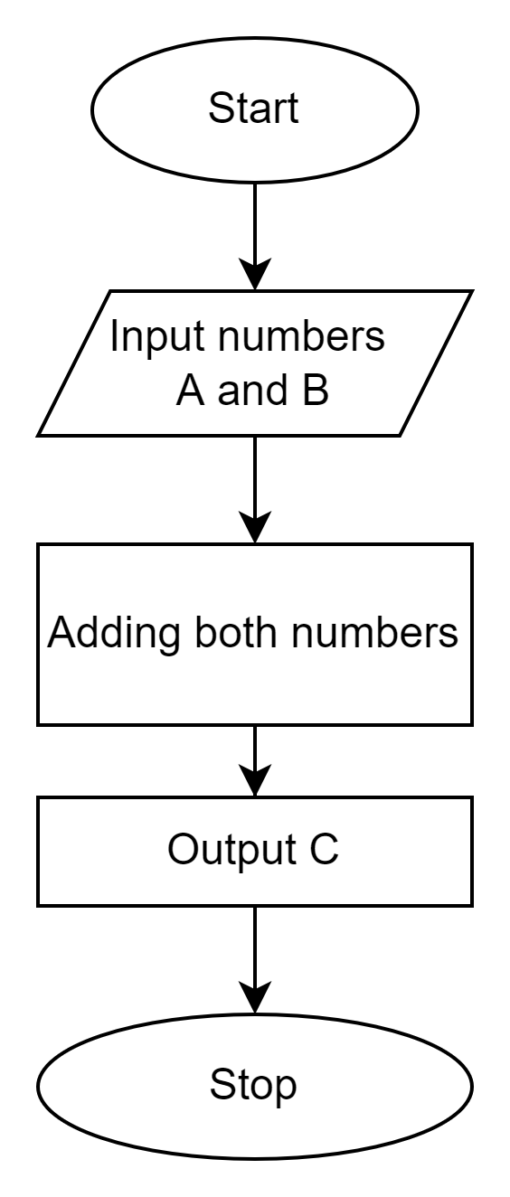

1. Converting temperature from Fahrenheit to Celsius

Step 1: Start

Step 2: Input the temperature in Fahrenheit

Step 3: Calculate the temperature with the formula C=5/9(F-32)

Step 4:Stop

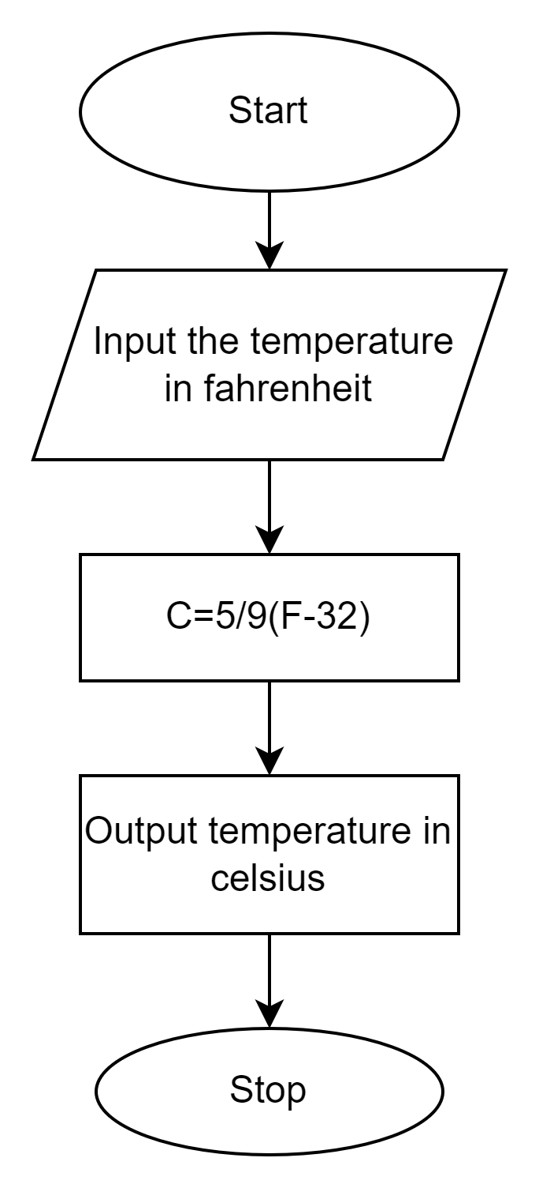

1. Finding the smallest of 2 numbers

Step 1: Start

Step 2: Input the two numbers num1 and num2

Step 3: Check whether num1 is the smallest number

Step 3.1: If so, then print ‘num1 is the smallest number’

Step 3.2: Else, then print ‘num2 is the smallest number’

Step 4: Stop

